Ramiro Francisco Batallas

[Email address]

Sitecore Hackathon 2020

Website developer with Sitecore 9.3

Wolfensteing team

Installation Instructions

# Installation Instructions

1. Install Sitecore 9.3
2. Download this package hackathon.wolfenstein.website.zip
3. Go to Developer Tools/ Installation Wizard
   1. 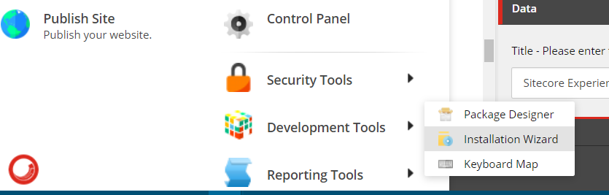
4. Upload the package and install it
   1. 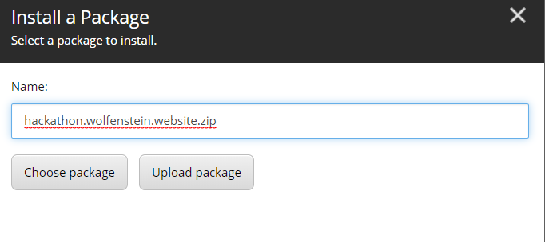
   2. 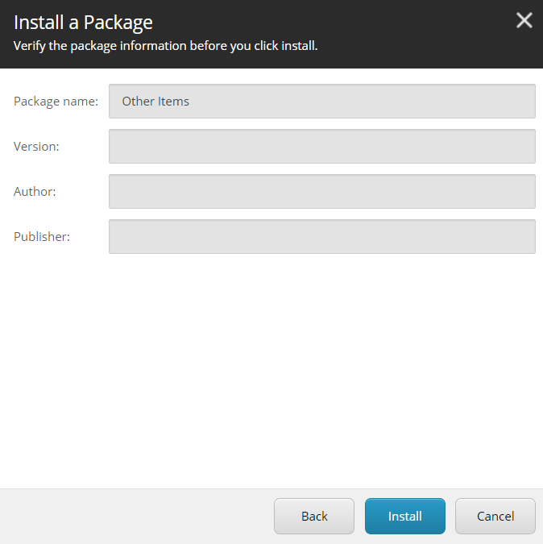
5. After the package is installed, go to content editor and verify all is in place
6. Publish all site and then review it with the url